**Historical Lessons on the Fate of America’s Oil Industry**

Finn Southerland

HSA10-5 The Economics of Oil and Energy

March 9, 2016

The Oil market is a very interesting and complicated place, especially in its current state of rapid flux and incredibly low prices, the like of which had not been seen for fifteen years until very recently [1]. So why are prices so low currently, what does that mean for producers, and what may happen in the coming months and years? Perhaps history has some lessons for us, after all oil prices have been extensively tracked for nearly a hundred years, essentially the whole life of the market. This essay will touch on the mechanics of the global oil market based on past events, lay out the situation today, and attempt to shed some light on the likely future of oil. Specifically, I will describe past events relating to the age-old supply and demand dynamic of economics, as well as the more oil specific spare capacity and reserve variables, all of which play a part in the current climate of low prices. With this framework in hand, I will illustrate today’s situation and the market forces at play, with the goal of framing some prediction about the future, currently a controversial topic worth much discussion.

**Section 1: Context**

At first glance, the oil market seems somewhat simple, controlled by the ever important supply and demand; “how much oil is there?” and “how much oil do people need?” are the simple questions that seem most potent. This first glance would be mostly right, with a few cave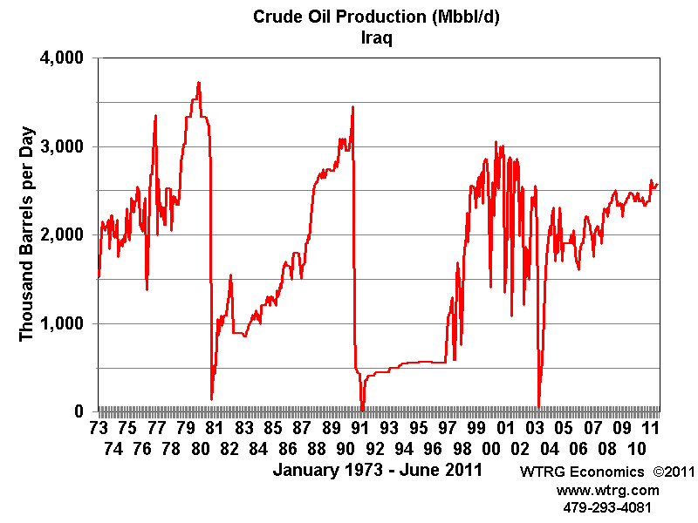ats which we will mention later. These principle of supply is well represented in times of conflict. In 1980, the Iraqi invasion of Iran caused both nations’ oil production to plummet, for a combined loss of 6.5 million barrels per day. This constituted ten percent of global oil production, and oil prices doubled because of this [2]. Changes in supply are also a tool often used by large producers to control prices, and we will talk about this in a moment. Demand is generally based on the state of the various economies of the world. Especially important to the history of oil trade have been the American and Asian economies. In the early and mid-1990s, strong economies on both areas were the largest factors in a steady price increase, but in 1998 the Asian economy slowed, and combined with an unwise increase in production, caused oil prices to fall again [2]. There is another case of lowered demand worth noting, which occurred around 1980. High oil prices in this period led to adaptation by consumers, such as better insulation in houses and energy efficiency, which in turn lowered demand [2]. This decrease in demand did not end when prices came down. After all, why would anyone purposefully return to costlier practices? Essentially, turmoil leads to lower supply, economic success leads to higher demand, and both lead to higher prices. In addition, high prices can lead some to change things in order to lower demand.

The next historical topic of importance is more oil specific than supply and demand – spare capacity is the ability of producers to make more oil than they are, without changing infrastructure. At first it may seem strange that anyone would produce less oil than they have the capability to, since it is so valuable. However, especially for those producers who control a large portion of the oil market, it is a price control tool. Places like Saudi Arabia have historically had high spare capacity, because if they used their full capacity supply would be too high, and prices would drop. Instead, by throttling production, they keep prices-and profit high. Large spare capacity basically gives large producers room to maneuver, giving them a measure of control over price. The spare capacity of Saudi Arabia has been the source of most of OPEC’s power over oil prices, as it gives a member a tool to manipulate prices [2]. An important note, especially today, is that having high spare capacity of necessity means one has lower actual production, and runs the risk of getting a lower market share – not selling as high a percentage of the global oil as possible. For larger producers there is a constant balancing act between maintaining market share and keeping prices high. Russia especially is currently having this problem, caught between barely profitable oil prices and fear of losing their market [3].

The most important historical context relating to spare capacity is its recent decline. In the early 2000s, a strike in Venezuela, which it has still not fully recovered from and the US invasion of Iraq caused both producers to lose a large portion of production. Combined with strong 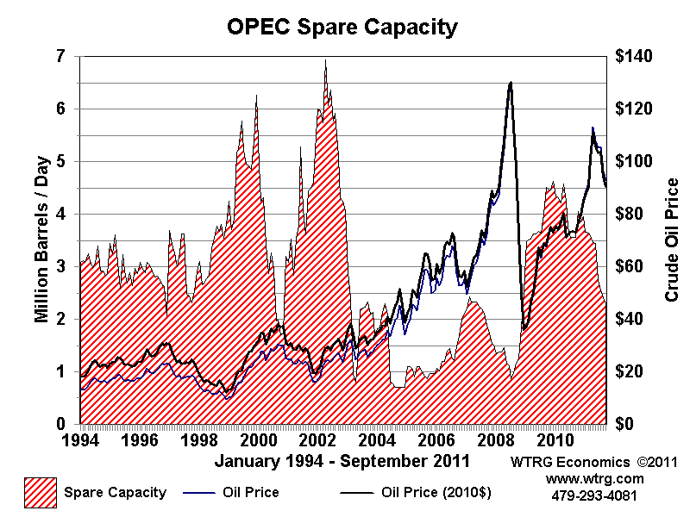economies and increased demand, other OPEC producers had to step up production to pick up the slack, causing their spare capacity to erode. The spare capacity in these times was so low that a loss of production in another sizeable supplier could not have been covered, and prices would have jumped, potentially damaging the global economy. The fear associated with low spare capacity actually lead to a significant price increase up until 2008 [2]. So spare capacity is not only a tool to effect changes in supply, but can also directly affect prices because of associated risk.

The last characteristic of the oil marketplace that I would like to touch on is on that is very relevant to the current situation. The amount of oil reserves held by varying consumers can have a huge impact on prices. This is expected, of course, when you consider that high reserves effectively reduce momentary demand by reducing the imminence of oil shortage in the case of a supply interruption. The case of oil futures in Cushing, Oklahoma around 2010. Normally, oil prices are affected by the predicted (“futures”) price in the near future, because when it is above the current, producers can threaten to store oil until the price has risen before delivering, forcing consumers to buy at a slightly higher price. In late 20120 and early 2011, however, increased supply in Cushing meant that there was no imminent demand for more oil, and producers lost this leverage. Because of this, prices in Cushing dropped significantly for a time.

**Section 2: Today**

With this solid background to stand on, let’s see if it gives us a better view of the present dynamics of oil prices. The reasons for today’s low prices are many and compound, involving most of the above factors. First, and most simply, demand is not as high as it could be, with fairly weak economies across the board, in the US, Europe, and China [4]. This is not terribly pronounced however, the larger problem is oversupply. Recently, advances in fracking and horizontal drilling in the US have greatly increased US production, and no othe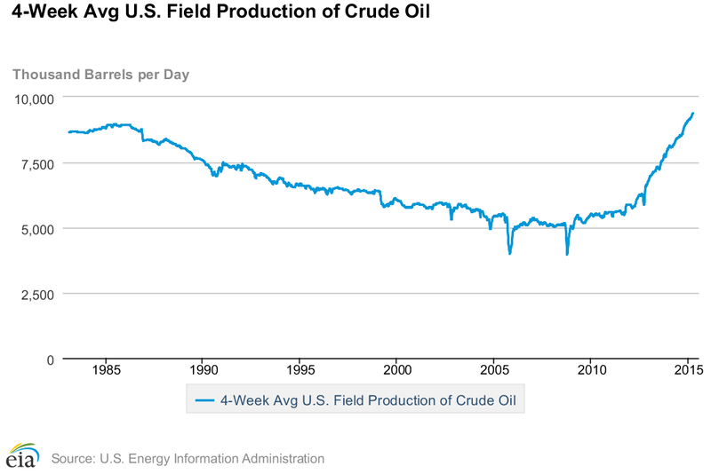r producers have stepped down production to make up for this [5]. It appears that many producers, such as Russia do not want to lose market share, and the largest producers, such as Saudi Arabia hope to simply crush the competition under the weight of lowered revenue [3]. At the core, it seems that everything comes down to who can last the longest with lower prices.

The complicating factor is that profits at the current price is not the sole factor. While American producers, with their higher cost of production are currently making little to no money, most OPEC countries actually need to make a certain profit to balance their governments’ budgets, and none of them are making this amount. The American economy is not as laser focused on oil as that of Nigeria or Kuwait. Most need oil prices closer to one hundred dollars per barrel in the long term, and are certainly feeling the pressure in the same way American companies are. The final necessary distinction here is that a few countries have enough saved to weather low prices for a time, and others need higher prices sooner rather than later. These richer countries are Saudi Arabia, the United Arab Emirates, and Kuwait, while countries including Nigeria, Iraq, and Iran cannot afford as such [3]. So who will actually go the distance? American oil companies could all collapse, or Russia, Nigeria, or Iraq could collapse, or they could all survive.

**Section 3: Predictions**

While drillers in the US have performed better under the current stresses of the market than most expected, they are still probably the first to deteriorate. This will especially happen as current wells dry up, which happens much sooner than Middle East wells in general, and new ones must be built. Building new wells may be too expensive a proposition for many US producers [6]. Compounding this is the large debts owed by many American drillers, which requires them to have a steady revenue stream in order to make payments. Overall, the higher cost of producing each barrel of oil for US companies than many of their competitors [7], along with these factors, indicates that American oil producers will be the first to fail. However, not all is doom and gloom for these players.

While it is likely that producers in the US will start going under first, it seems unlikely that more than about one-sixth of US oil production should be ultimately affected. To see this, we need to compare two numbers: total oil production in the US, and OPEC spare capacity. Once oil production begins to fall significantly in the US, oil prices will rise – unless someone else, namely OPEC producers, raise production to keep supply steady. Otherwise, lower supply would raise prices, saving the remaining producers from failure. However, current US production of oil is about nine million barrels per day [8], while OPEC spare capacity is only about 1.5 million barrels per day [9], and much of this will probably continue to be unutilized. Therefore, OPEC can only hold prices down through the loss of about one-sixth of US production at a maximum before prices rise in response to lower supply.

[1653 words]

[1] "Crude Oil Price History Chart | MacroTrends." Crude Oil Price History Chart | MacroTrends. Accessed March 6, 2016. http://www.macrotrends.net/1369/crude-oil-price-history-chart.

[2] Williams, James L. "History and Analysis -Crude Oil Prices." History and Analysis -Crude Oil Prices. Accessed March 6, 2016. http://www.wtrg.com/prices.htm.

[3] Bowler, Tim. "Falling Oil Prices: Who Are the Winners and Losers? - BBC News." BBC News. January 19, 2015. Accessed March 6, 2016. http://www.bbc.com/news/business-29643612.

[4] "OMR - OMR Public." OMR - OMR Public. March 6, 2016. Accessed March 6, 2016. https://www.iea.org/oilmarketreport/omrpublic/.

[5] Plumer, Brad. "Why Crude Oil Prices Keep Falling and Falling, in One Simple Chart." Vox. February 08, 2016. Accessed March 6, 2016. http://www.vox.com/2016/1/12/10755754/crude-oil-prices-falling.

[6] Plumer, Brad. "Oil Prices Crashed, but US Output Is Still Rising. How Long Can That Last?" Vox. March 27, 2015. Accessed March 6, 2016. http://www.vox.com/2015/3/27/8301165/oil-production-low-prices.

[7] Kristopher, Gordon. "Welcome to Market Realist." Crude Oil's Total Cost of Production Impacts Major Oil Producers. January 13, 2016. Accessed March 6, 2016. http://marketrealist.com/2016/01/crude-oils-total-cost-production-impacts-major-oil-producers/.

[8] "Weekly US Field Production of Crude Oil." US Energy Information Administration. March 4, 2016. Accessed March 6, 2016. https://www.eia.gov/dnav/pet/hist/LeafHandler.ashx?n=PET&s=WCRFPUS2&f=W.

[9] "U.S. Energy Information Administration - EIA - Independent Statistics and Analysis." Energy & Financial Markets. Accessed March 6, 2016. https://www.eia.gov/finance/markets/supply-opec.cfm.